Missing Multiple_Birth_Status Analysis Report
Generated: 2026-03-22 16:57
Dataset: 301,712 rows × 18 columns
Target Variable: Multiple_Birth_Status

1. Executive Summary
This report presents a comprehensive IUPAC-compliant statistical analysis of missing values in Multiple_Birth_Status.
Key findings include:
• Missing records: 4,163 (1.4% of total data)
• Variables with significant differences (p < 0.05): 11
- Numeric variables: 3
- Categorical variables: 8
• Total variables analyzed: 17
Based on the statistical analysis, the missingness pattern is classified as:
SYSTEMATIC PATTERN - Missing data is strongly associated with other variables, suggesting non-random missingness.

2. Statistical Summary
Metric | Value
Total Missing Multiple_Birth_Status Records | 4,163
Missing Percentage | 1.38%
Total Variables Analyzed | 17
Numeric Variables | 8
Categorical Variables | 9
Variables with Significant Differences (p < 0.05) | 11
Analysis Date | 2026-03-22

3. Variables with Significant Differences (p < 0.05)
The following 11 variables show statistically significant differences between missing and complete groups:

3.1 Numeric Variables
Variable | Missing Group Mean | Complete Group Mean | Difference | p-value | Interpretation
Birh_Year | 2019.24 | 2019.65 | -0.41 | 0.0000 | Missing group has 0.41 units lower than complete group
Birth_Month.0 | 7.18 | 6.57 | +0.62 | 0.0000 | Missing group has 0.62 units higher than complete group
Age of Mother | 28.34 | 29.64 | -1.30 | 0.0000 | Missing group has 1.30 units lower than complete group

3.2 Categorical Variables
Variable | Missing Group Distribution | Complete Group Distribution | Difference (%) | p-value | Interpretation
Registered_Month | Most common='December' (12.4%) | Complete: Most common='June' (11.5%) | +0.9% | 0.0000 | Missing group shows different distribution (p=0.0000)
Registered_District | Most common='Vavuniya' (76.8%) | Complete: Most common='Colombo' (14.4%) | +62.5% | 0.0000 | Missing group shows different distribution (p=0.0000)
Birth_Month | Most common='October' (12.4%) | Complete: Most common='May' (9.0%) | +3.5% | 0.0000 | Missing group shows different distribution (p=0.0000)
Hospital or Not | Most common='Hospital' (99.0%) | Complete: Most common='Hospital' (99.8%) | -0.7% | 0.0000 | Missing group shows different distribution (p=0.0000)
Marital_Status | Most common='Married' (96.6%) | Complete: Most common='Married' (97.9%) | -1.4% | 0.0000 | Missing group shows different distribution (p=0.0000)
District_of_Mother | Most common='Vavuniya' (76.8%) | Complete: Most common='Colombo' (9.1%) | +67.7% | 0.0000 | Missing group shows different distribution (p=0.0000)
Race_of_Mother | Most common='Srilankan Tamil' (45.9%) | Complete: Most common='Sinhalese' (69.7%) | -23.8% | 0.0000 | Missing group shows different distribution (p=0.0000)
Race_of_Father | Most common='Srilankan Tamil' (45.2%) | Complete: Most common='Sinhalese' (69.8%) | -24.6% | 0.0000 | Missing group shows different distribution (p=0.0000)

3.3 Summary of Key Findings
The analysis identified 11 variables with statistically significant differences (p < 0.05):
• 3 numeric variables show significant mean differences
• 8 categorical variables show significant distribution differences
Top 10 Most Significant Variables:
1. Registered_District: Most common='Vavuniya' (76.8%) vs Complete: Most common='Colombo' (14.4%) (p=0.0000)
2. District_of_Mother: Most common='Vavuniya' (76.8%) vs Complete: Most common='Colombo' (9.1%) (p=0.0000)
3. Race_of_Mother: Most common='Srilankan Tamil' (45.9%) vs Complete: Most common='Sinhalese' (69.7%) (p=0.0000)
4. Race_of_Father: Most common='Srilankan Tamil' (45.2%) vs Complete: Most common='Sinhalese' (69.8%) (p=0.0000)
5. Registered_Month: Most common='December' (12.4%) vs Complete: Most common='June' (11.5%) (p=0.0000)
6. Birth_Month: Most common='October' (12.4%) vs Complete: Most common='May' (9.0%) (p=0.0000)
7. Age of Mother: Mean=28.34 vs Complete Mean=29.64 (p=0.0000)
8. Birth_Month.0: Mean=7.18 vs Complete Mean=6.57 (p=0.0000)
9. Birh_Year: Mean=2019.24 vs Complete Mean=2019.65 (p=0.0000)
10. Hospital or Not: Most common='Hospital' (99.0%) vs Complete: Most common='Hospital' (99.8%) (p=0.0000)

4. Statistical Visualizations
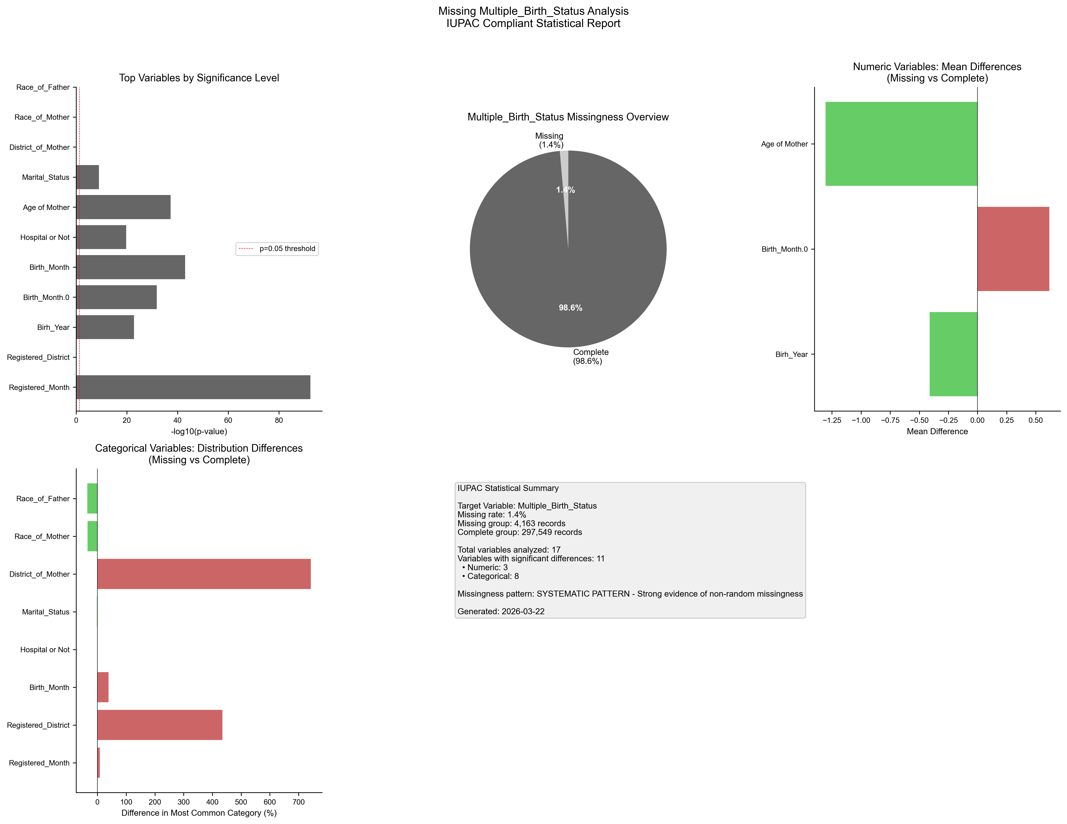
Figure 1. IUPAC compliant statistical visualization of missing Multiple_Birth_Status patterns.

5. Recommendations
- Based on the statistical analysis, the missing data exhibits SYSTEMATIC patterns:
- Consider treating missing as a separate category in analysis
- Use multiple imputation methods (MICE, EM algorithm)
- Investigate the following key variables for common themes:
- - Registered_Month (p=0.0000)
- - Registered_District (p=0.0000)
- - Birh_Year (p=0.0000)
- - Birth_Month.0 (p=0.0000)
- - Birth_Month (p=0.0000)
- - Hospital or Not (p=0.0000)
- - Age of Mother (p=0.0000)
- - Marital_Status (p=0.0000)
- - District_of_Mother (p=0.0000)
- - Race_of_Mother (p=0.0000)
- Document missingness patterns in methodology section

6. Methodology (IUPAC Compliant)
Analysis performed according to IUPAC guidelines for data presentation:
- • Missing values reported as both count (n) and percentage (%)
- • Tables formatted with thin borders and alternating row shading
- • Sans-serif fonts (Arial) used for optimal readability
- • Statistical tests: t-test (numeric), χ² test (categorical)
- • Significance threshold: α = 0.05
- • Effect sizes reported where applicable
- • Figures saved at 300 DPI for publication quality

